ONLINE NGO WEBSITE

DBMS MINI PROJECT REPORT
Submitted to
Visvesvaraya Technological University BELAGAVI - 590018
Raksha Shetty USN: 4SU20IS034

Sinchana v Shetty USN: 4SU20IS041

Under the guidance of
Dr.G.P.Hegde
HoD (Incharge)

In partial fulfillment of the requirements for the award of the degree of

Bachelor of Engineering



Department of Information Science and Engineering
Ujire -574240
2022-2023
SDM INSTITUTE OF TECHNOLOGY
(Affiliated to Visvesvaraya Technological University, Belagavi)
Ujire -574240
Department of Information Science and Engineering
CERTIFICATE
Certified that the Mini Project Work titled “Online NGO Website’’ is carried out by Ms.Raksha Shetty, USN: 4SU20IS034 and Ms.Sinchana V Shetty, USN: 4SU20IS041, bonafied students of SDM Institute of Technology, Ujire, in partial fulfillment for requirement for 5th semester DBMS Laboratory With Mini Project in Information Science and Engineering of Visvesvaraya Technological University, Belagavi during the year of 2022-2023. It is certified that all the corrections/ suggestions indicated for Internal Assessment have been incorporated in the report deposited in the departmental Library- The report has been approved as it satisfies the academic requirements in respect of mini project work prescribed for the said Laboratory.

Dr.G.P.Hegde Dr. G.P.Hegde Dr. Ashok Kumar T
Associate Professor and Guide HoD (Incharge) Principal

Signature with date and seal:

External Viva
Name of the Examiners: Signature with Date

ACKNOWLEDGEMENT

We express our deepest gratitude to our guide Dr. G.P.Hegde Associate Professor and Prof. Naveen Pagad Assistant Professor, Department of Information Science and Engineering, for their valuable guidance and encouragement while doing this mini project work.
We are indebted to Dr. G.P.Hegde Head of the Department (Incharge) and Dr. Ashok Kumar T Principal, for their advice and suggestions at various stages of the work.
We also extend our thanks to the management of SDM Institute of Technology, Ujire, for providing an excellent study environment, reference materials and Laboratories facilities. We remain grateful to the cooperation and help rendered by the teaching and non-teaching staff of the department.

Raksha shetty & Sinchana V shetty

ABSTRACT

This website work generally summarizes the activities carried out in the design and implementation of the web based NGO management system . This NGO Management is a non -profit organization system in which donors can come in and request and donate materials such as cloths, hospital equipment, foods, books etc these objectives creating login and register page, even letting them go through donating essential items required for the people. Here volunteers can register to our website and conduct tasks like awareness programs. They voluntarily conduct the tasks which will benefit the society. This website connects society to the people who want to make difference in the society.

Table of Contents
Chapters: page no.
- Introduction 1
- Objective 2
- Methodology 3
3.1 Use case diagram for NGO……………………………………….3
- Literature Survey……………… ………………………………………4
  - HTML………………………………………………………….. 4
  - PHP…………………………………………………………….. 4
  - XAMPP………………………………………… …………….. 4
- Requirement Specification…………………………….. ……………. 5
  - Hardware requirement specification…………………………… 5
  - Software requirement specification……………………………. 5
- System design…………………………………………. ……………. .6
  - ER diagram……………………………………………………... 6
  - Schema diagram…………………………………………………7
- Implementation………………………………………………………...8
  - Implementation of HTML page…………………………………8
  - Implementation of PHP page……………………………………8
  - Implementation of CSS……………………………………….....9
- Results…………………………………………………………………10-15
- Conclusion……………………………………………………………16
- References…………………………………………………………….17

Chapter 1

INTRODUCTION
Problem Statement and Solution:
When some issues are not solved or reached to the government this project plays an important role in conveying these issues and some issues which are intentionally looked down by the government then these project look after those issues. This website is free from the control of government control. These are said to be non-profit governmental bodies which work for the welfare of societies . they act as a mediator between society and the government.
This project uses MySQL Database which allows to store the wide range of details about the information. The frontend of the website is designed by using HTML, and CSS while the backend is designed with Php.

1

Chapter 2

OBJECTIVES
- To design website such a system to improve the services
- To decrease the time spent on calls and searching offered in the donation
- To manage and distribute the contributions done by the people to the needy

2
Chapter 3

METHODOLOGY
- Making of front end.
- Creating various table in database as needed.
- Connection of front end to back end (connection of forms to database)
➢ Updation of candidates detail by admin.
- Doing respective jobs.
- Declaring of result.
3.1:Use case for diagram for NGO:

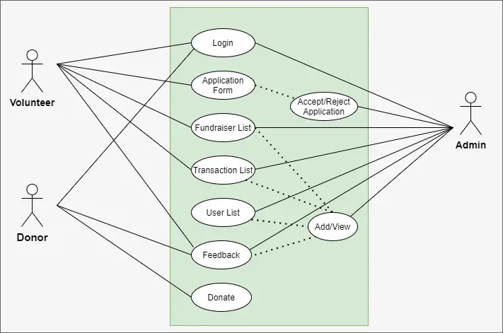
Figure 3.1:Use case diagram
3
Chapter 4

LITERATURE SURVEY

4.1 HTML
HTML is short for Hypertext Markup Language. HTML is used to create electronic documents (called pages) that are displayed on the world wide web. Each page contains a series of connections to other pages called hyperlinks. Every web page on the internet is written using one version of HTML code or another.
HTML code ensures the proper formatting of text and images for Internet browser. Without HTML, a browser would not know how to display text as elements or load images or other elements. HTML also provides a basic structure of the page, upon which Cascading style sheets are overlaid to change its appearance. One could think HTML as structure of a web page, and CSS as its appearance.

4.2 PHP
PHP is a server side scripting language that is embedded in HTML. It is used to manage dynamic content, databases, session tracking. It is used to build entire e-commerce site. It is integrated with a number of popular databases, including MySQL, PostgresSQL, Oracle, Sybase, Informix and Microsoft SQL server.
4.3 XAMPP
Xampp is quite a well-known term among website hosting services industry. XAMPP is acronym for the combination of windows, Apache, MySQL and PHP/Python/Perl. In this combination the first three are constant ones and for the fourth one it varies among PHP, Python and Perl. There may be a few occasions in which Python and Perl can be used together. The reason behind the popularity of XAMPP is because it provides four important elements operating system, Database web server and scripting application which are required for a web hosting server. When all these four elements are used as combined then such a usage is called as ‘Server Stack’. In this (XAMPP) server stack you use Microsoft Windows as an operating system,
Apache’ as a web Server, MySQL to work as a Database and you can choose one from PHP, Python and Perl to be used as scripting language XAMPP it is totally related with windows web hosting servers and has nothing to do with Linux Hosting servers.

4
Chapter 5

REQUIREMENT SPECIFICATION

5.1 Hardware Requirements
- Processor Intel i5 core

- Clock speed 1.50GHz

- Monitor 1920*1080 Resolution, Color

- RAM 8GB

- Hard disk Minimum 1TB

- Keyboard Normal

5.2 Software Specification
- Windows 10 operating System
- Visual studio code(for coding HTML,CSS,PHP)
- Database-MySQL
- Xampp server V 3.3.0 tool
- PhpMyAdmin 8.0.13
- Microsoft edge/Google chrome

5

Chapter 6

SYSTEM DESIGN

6.1 ER Diagram

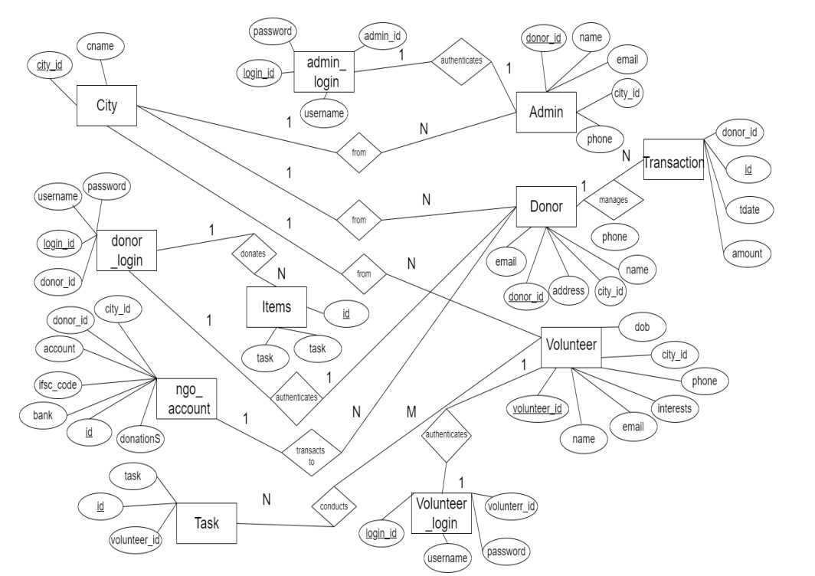

Figure 6.1: ER Diagram

6

6.2 Schema Diagram

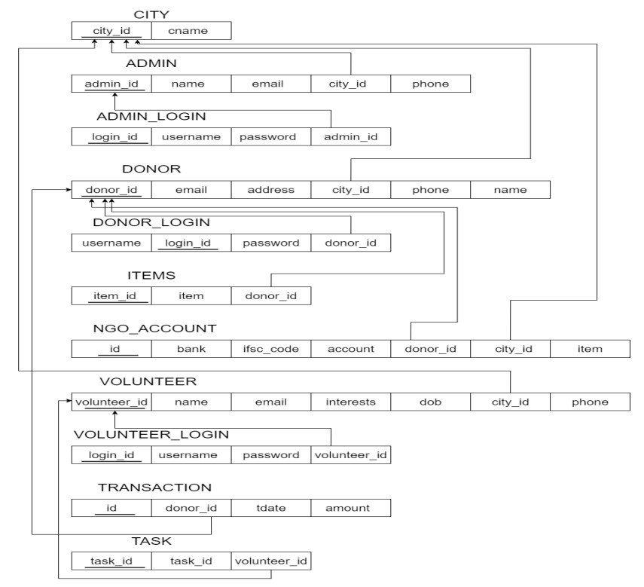
Fig 6.2: Schema Diagram

7

Chapter 7

IMPLEMENTATION

7.1 Implementation of HTML Page
<!DOCTYPE html>
<html>
<head>
<title Title of the page</title>
<style>I/CSS code to be written here</script>
</head>
</body>//html code to be written here</body>
</html>
The above code represents skeleton of HTML implementation. The title is within title tag. The HTML code is written within body tag. Formatting of contents of HTML is done by CSS which is written within the script tag. Whole HTML code is enclosed within html tag.
7.2 Implementation of PHP Page :
PHP code can be embedded within an html file. PHP file will usually have the extension php. The below code is the code used to as an extension used when the user sends an email to the admin.

<!DOCTYPE html>
<html>
<body> <?php echo “Myfirst PHP script!”;
?>
</body>
</html>?>

8

7.3 Implementation of CSS
CSS is used to define the presentation of HTML documents. With CSS, we can assign font properties, colours, size, borders, background images, and even position elements on the page. CSS uses a special tag called <style>inside which CSS elements are written.
Look at the following CSS code (the h1,h2,and p elements have the same style definitions):

<style>

h1 {

text -align: center;

color: red;

}

h2{

text-align: center;
color: red;
}

P {
text-align: center;
color: red;

}
</style>

9

Chapter 8 RESULTS

Home page: Home page of the website.

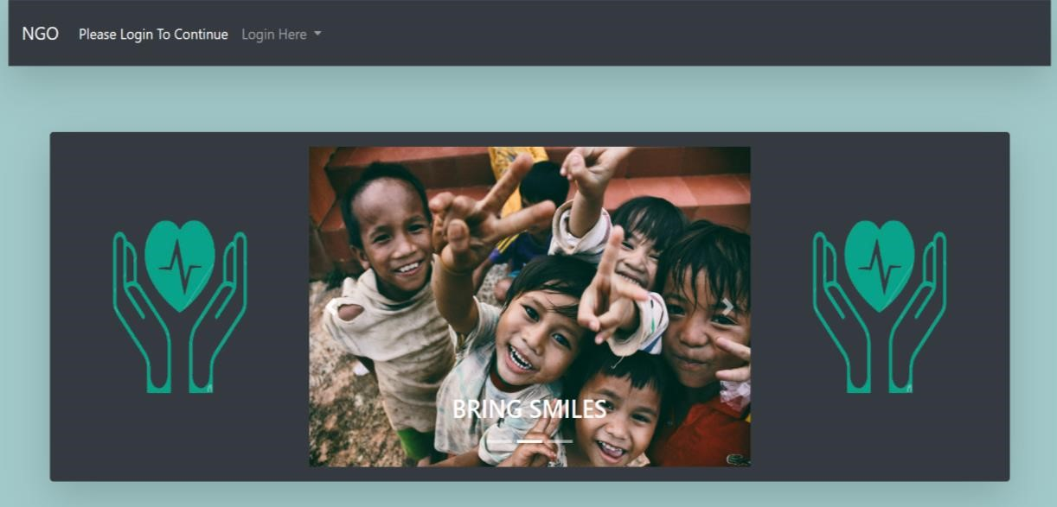

Figure 8.1: Home page
Login page: Page to login for existing admin.

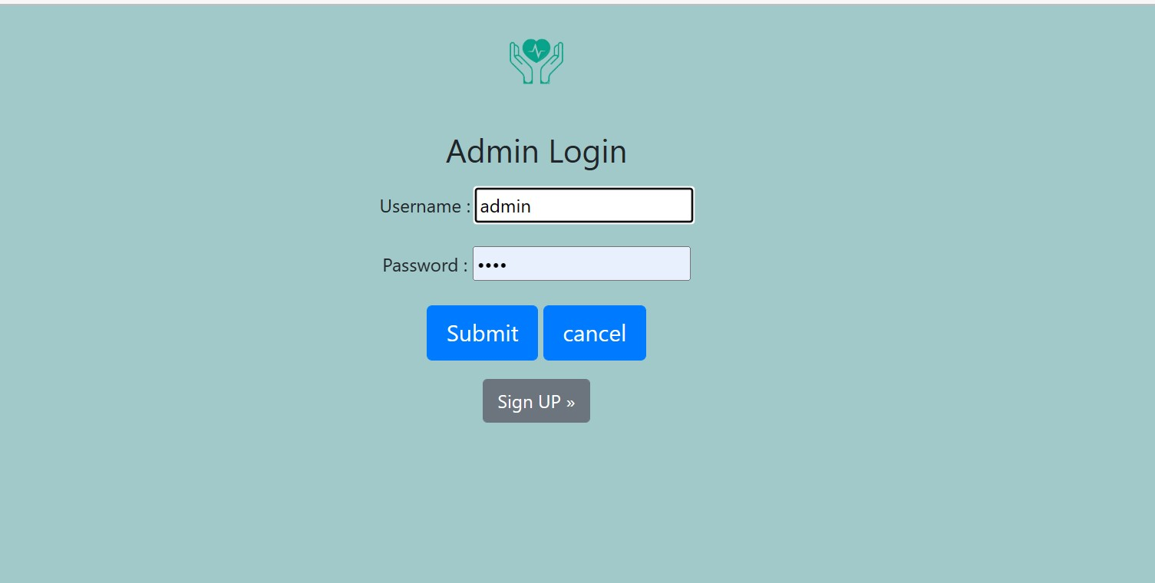

Figure 8.2 Login page

10
Sign up Page: Page to create a new admin

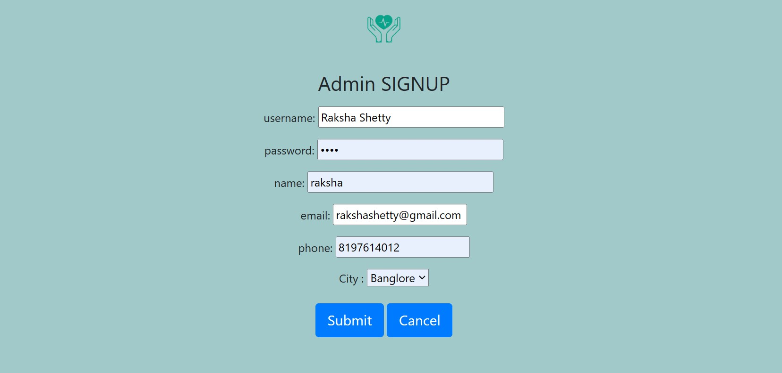

Figure 8.3:: Admin Signup Page

Product Category: Admin home page

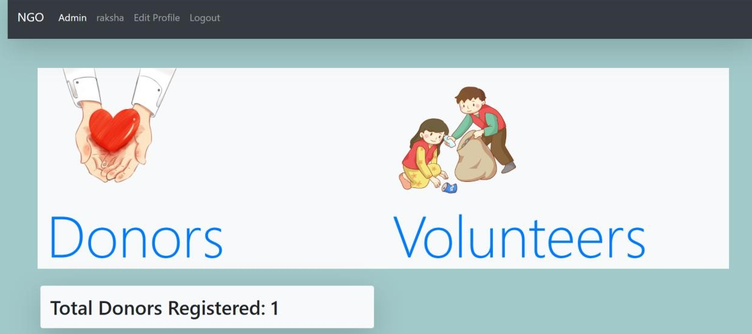
Figure 8.4: Admin home page

11
Detail Information: Full Information about donors to admin.

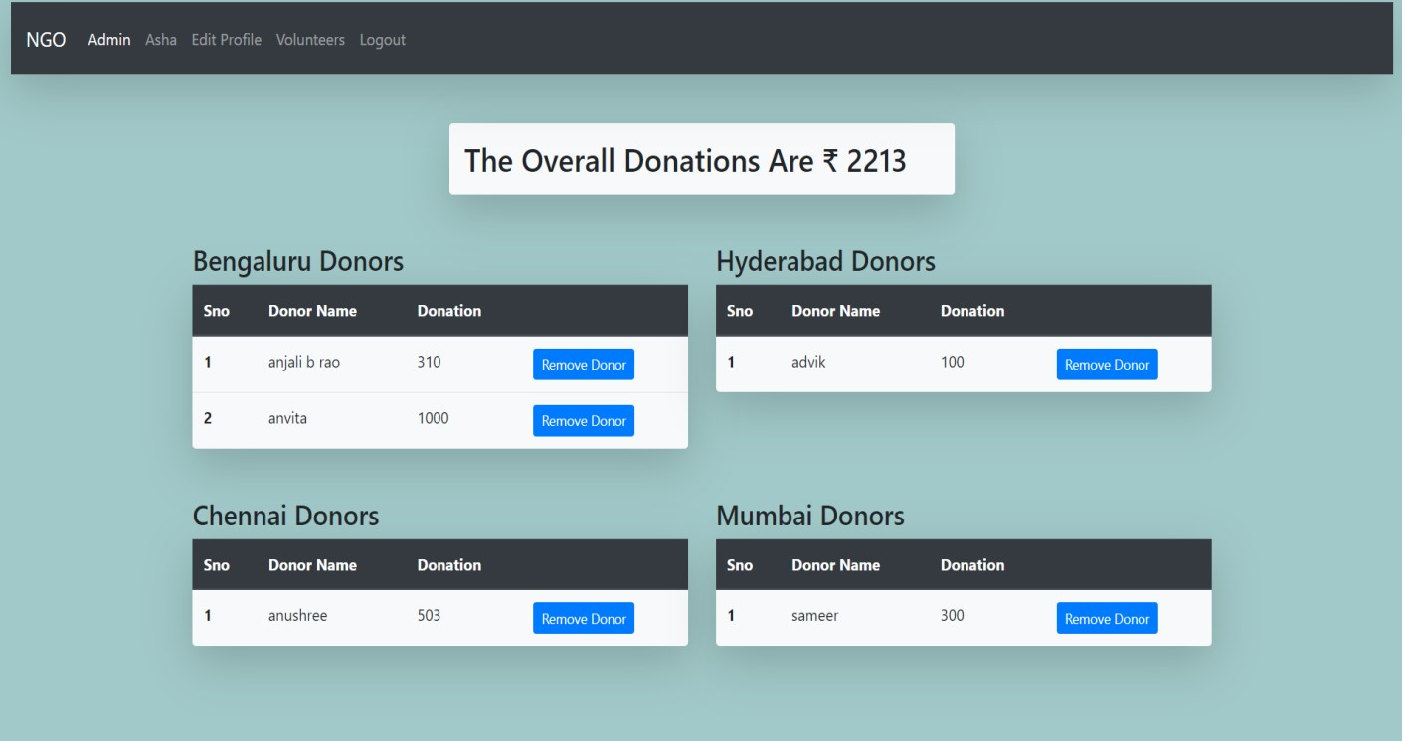

Figure 8.5: Detailed Information of donors

Detail Information: Full Information about volunteers to admin

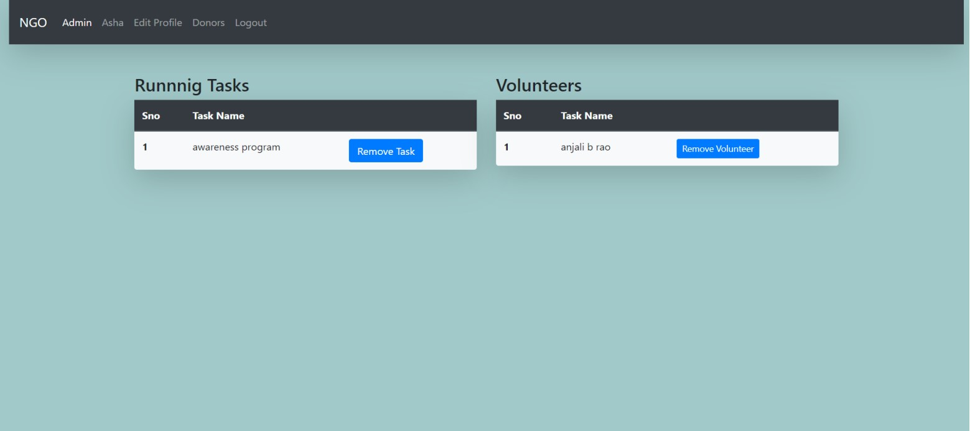

Figure 8.6: Detailed Information of volunteers

12
Donar login page: donor login page

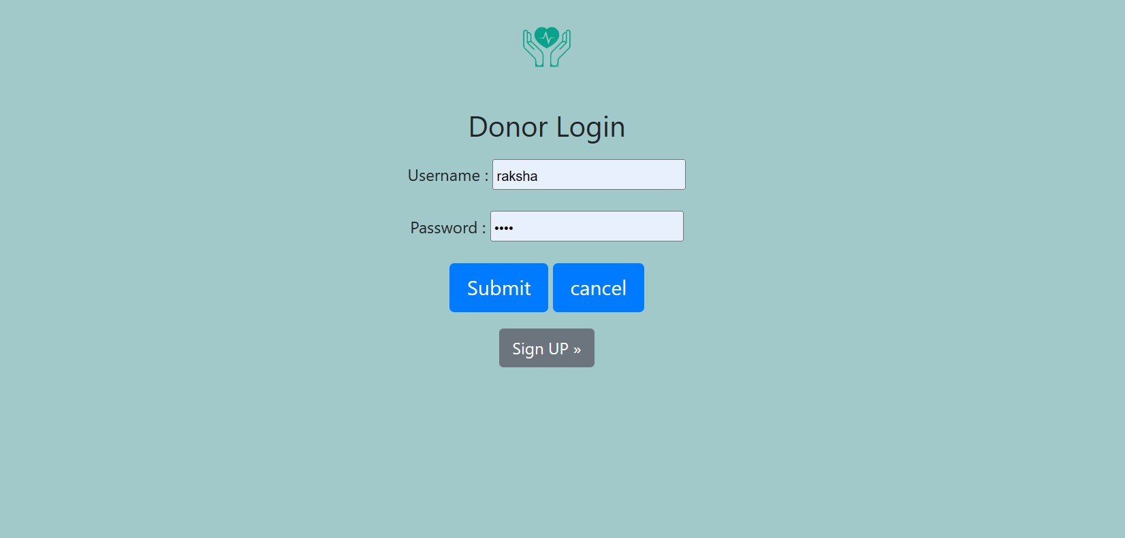

Figure 8.7 : Donor login page

Donor Signup Page: donor signup page

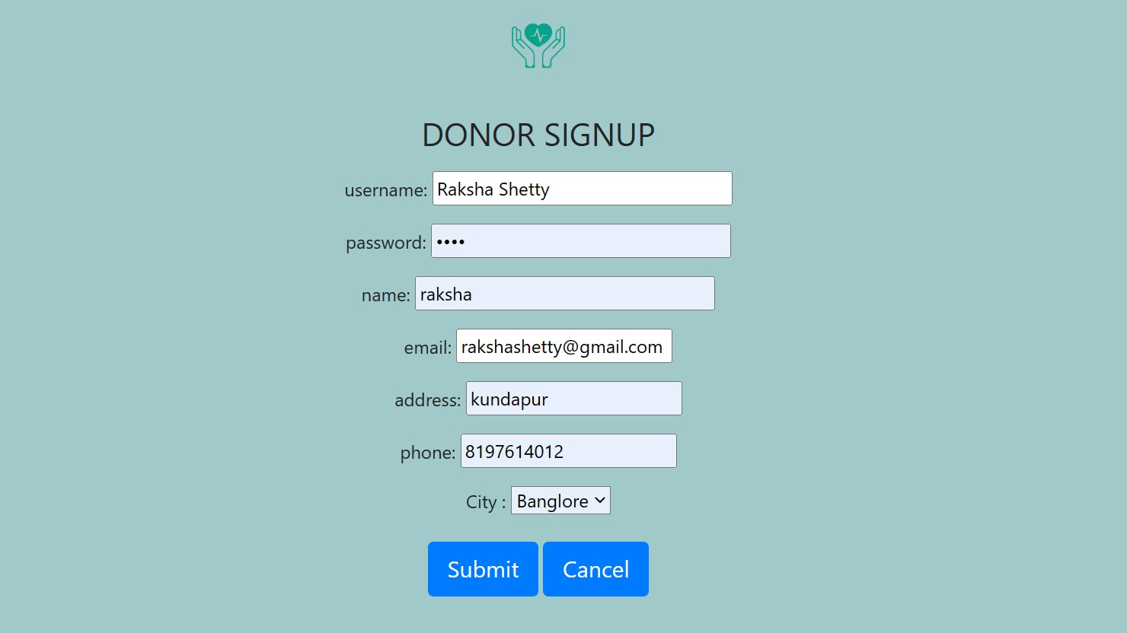
Figure 8.8: Donor signup

13
Donor home page: donor home page

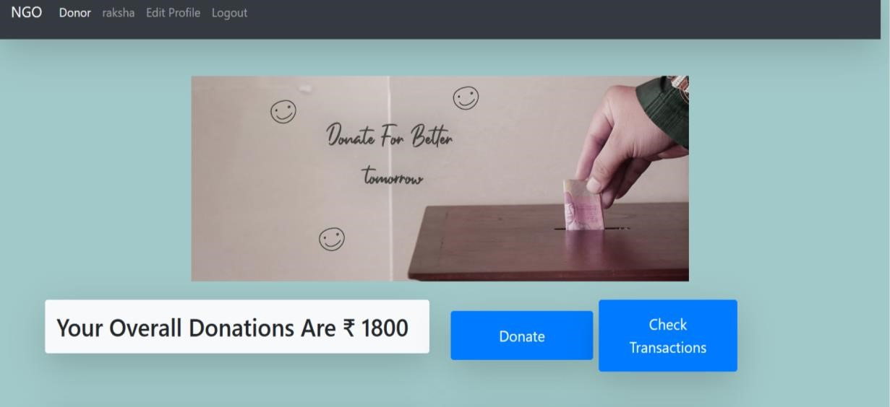

Figure8.9Donor home page

Donor donation page: donor donation page


Donor items page: donor items page

Figure 8.10: Donor page

14
Volunteer page: page

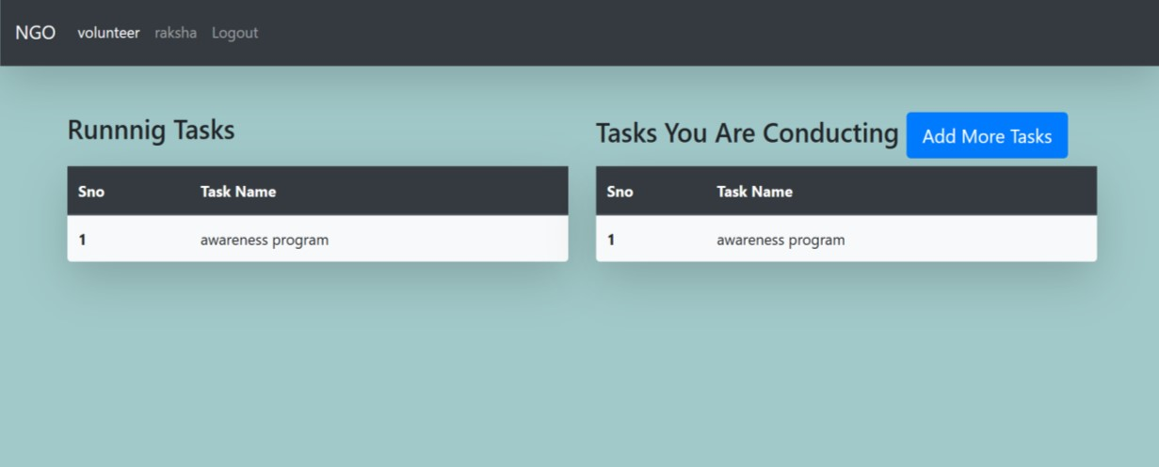
Figure 8.11: Volunteer page

Volunteer page: updating volunteer information

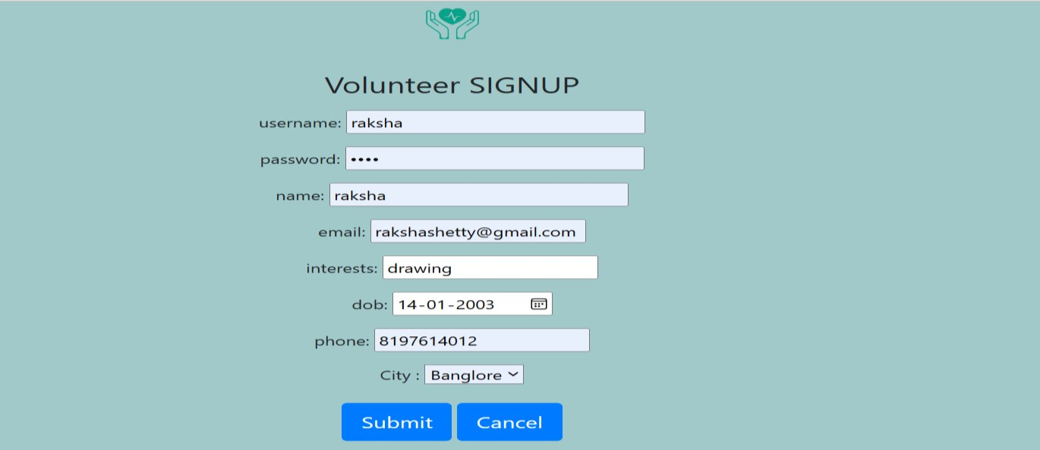

Figure 8.12: Volunteer update page

15

Chapter 9

CONCLUSION

In conclusion NGO’s are meant for the general betterment of society. The allocation of donations must be strictly monitored to ensure that it does not end up in the wrong hands. There is much hardship in the world, and it is the fortunate man’s inherit duty to help better those who are less fortunate. In this mini project we are aiming to help needy people by gathering volunteers and donors. Through helping another in need, one is able to dignify their own life with the pride of helping someone else. This mini project is proposed with the view of aiding the people by giving them essential requirements.

16

Chapter 10

REFERENCES

- Fundamentals of Database Sysetm, Ramez Elmasri and Shamkat B,Navathe,7th edition.
- https://youtu.be/PXugYdXCBck
- https://stackoverflow.com/questions/tagged/mysql
- https://youtu.be/y5mBHPtEO5w
- https://www.w3schools.com/bootstrap/

17

PERSONAL PROFILE


Dr. G. P. Hegde received PhD degree in Computer Science and Engineering from Visvesvaraya Technical University (VTU) Belgaum. India, in 2018. Presently he is working as Associate Professor and Head of the department (incharge) in Information Science Engineering department of SDMIT Ujire affiliated to Visvesvaraya Technical University (VTU) Belgaum. He has published over 32 technical publications and proceedings. His research interests comprise Image processing, Pattern recognition, Computer Networks, Software engineering, Software architecture. He is a reviewer committee member of many international journals. Email gphegde@sdmit.in
Mobile:9448418290

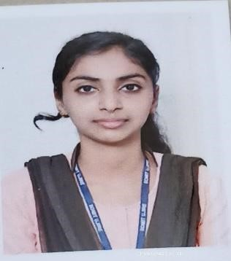
  Name: Raksha Shetty
  USN: 4SU20IS034
  E-mail ID: shettyraksha659@gmail.com
  Contact no: 8197614012

Name: Sinchana V Shetty
USN:4SU20IS041
E-mail ID: shettysinchana17@gmail.com
Contact no: 9483572554


